**Experiment 6**

**Q1) Write a script to check whether number is positive or negative.**

**Code:**

#!/bin/bash

read -p "enter the number" a

if [ $a -gt 0 ]

then

echo "the number is a positive number"

elif [ $a -le 0 ]

then

echo "the number is a negative number"

else

echo "Zero"

fi

**Output:**

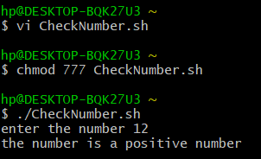

**Q2) Write a script to find greatest number among three numbers.**

**Code:**

#!/bin/bash

read -p "enter the first number a=" a

read -p "enter the second number b=" b

read -p "enter the third number c=" c

if [ $a -gt $b -a $a -gt $c ]

then

echo "$a is greater"

elif [ $b -gt $a -a $b -gt $c ]

then

echo "$b is greater"

else

echo "$c is greater"

fi

**Output:**

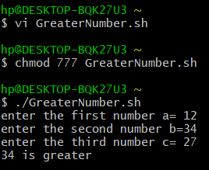

**Q3) Write a script to enter the marks of a student. If the marks are greater than 70 display grade A, if the grade is greater than 60 and less than 70 display grade B, else display “Fail”.**

**Code:**

#!/bin/bash

read -p "enter the marks of the student" m

if [ $m -gt 70 ]

then

echo "A Grade"

elif [ $m -le 70 -a $m -gt 60 ]

then

echo "B Grade"

else

echo "Fail"

fi

**Output:**

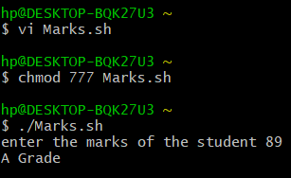

**Q4) Write a script to calculate factorial of a number.**

**Code:**

#!/bin/bash

echo Enter a number:

read a

fact=1

for (( i=$a; i > 1; i-- ))

{

fact=$((fact*i))

}

echo The factorial of a number is $fact

**Output:**

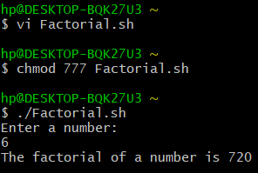

**Q5) Write a script to display whether a user is valid or not.**

**Code:**

#!/bin/bash

echo Enter the user name:

read uname

if [ "$uname" = "$USER" ]

then

echo Valid User Name

else

echo Invalid User Name

fi

**Output:**

